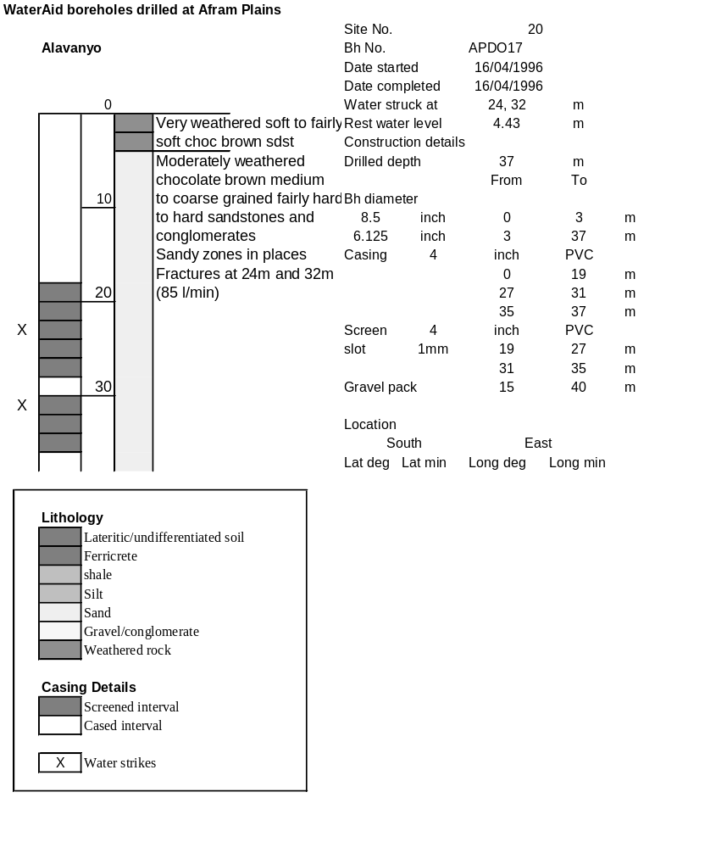

Ghana | Test pumping
Borehole No. |  | APDO17
Hole No |  | 20
Village |  | Alavanyo
Date |  | 29/04/1996
Point above GL |  | 0.5 | m
Pump depth |  | 28 | m
SWL |  | 4.93 | m
Start Time |  | 07:55
Drawdown test |  |  |  |  | Recovery test
time | pwl (m) | Q l/min | dd | sc | Time | wl (m) | s' | t/t'
0.00 | 4.93 | 60.00 | 0.00 |  | 0.00 | 11.46 | 6.53
1.00 | 8.30 | 60.00 | 3.37 | 17.80 | 1.00 | 8.38 | 3.45 | 181.00
2.00 | 9.17 | 60.00 | 4.24 | 14.15 | 2.00 | 7.25 | 2.32 | 91.00
3.00 | 9.65 | 60.00 | 4.72 | 12.71 | 3.00 | 6.68 | 1.75 | 61.00
4.00 | 9.97 | 60.00 | 5.04 | 11.90 | 4.00 | 6.35 | 1.42 | 46.00
5.00 | 10.18 | 60.00 | 5.25 | 11.43 | 5.00 | 6.16 | 1.23 | 37.00
6.00 | 10.36 | 60.00 | 5.43 | 11.05 | 6.00 | 6.03 | 1.10 | 31.00
7.00 | 10.46 | 60.00 | 5.53 | 10.85 | 7.00 | 5.93 | 1.00 | 26.71
8.00 | 10.54 | 60.00 | 5.61 | 10.70 | 8.00 | 5.85 | 0.92 | 23.50
9.00 | 10.61 | 60.00 | 5.68 | 10.56 | 9.00 | 5.76 | 0.83 | 21.00
10.00 | 10.67 | 60.00 | 5.74 | 10.45 | 10.00 | 5.73 | 0.80 | 19.00
11.00 | 10.73 | 60.00 | 5.80 | 10.34 | 12.00 | 5.68 | 0.75 | 16.00
12.00 | 10.78 | 60.00 | 5.85 | 10.26 | 14.00 | 5.63 | 0.70 | 13.86
13.00 | 10.80 | 60.00 | 5.87 | 10.22 | 16.00 | 5.59 | 0.66 | 12.25
14.00 | 10.84 | 60.00 | 5.91 | 10.15 | 18.00 | 5.54 | 0.61 | 11.00
15.00 | 10.86 | 60.00 | 5.93 | 10.12 | 20.00 | 5.50 | 0.57 | 10.00
16.00 | 10.88 | 60.00 | 5.95 | 10.08 | 22.00 | 5.47 | 0.54 | 9.18
17.00 | 10.92 | 60.00 | 5.99 | 10.02 | 24.00 | 5.43 | 0.50 | 8.50
18.00 | 10.95 | 60.00 | 6.02 | 9.97 | 26.00 | 5.40 | 0.47 | 7.92
19.00 | 10.95 | 60.00 | 6.02 | 9.97 | 28.00 | 5.38 | 0.45 | 7.43
20.00 | 10.96 | 60.00 | 6.03 | 9.95 | 30.00 | 5.35 | 0.42 | 7.00
22.00 | 10.98 | 60.00 | 6.05 | 9.92 | 35.00 | 5.30 | 0.37 | 6.14
24.00 | 11.03 | 60.00 | 6.10 | 9.84 | 40.00 | 5.26 | 0.33 | 5.50
26.00 | 11.04 | 60.00 | 6.11 | 9.82 | 45.00 | 5.23 | 0.30 | 5.00
28.00 | 11.05 | 60.00 | 6.12 | 9.80 | 50.00 | 5.20 | 0.27 | 4.60
30.00 | 11.09 | 60.00 | 6.16 | 9.74 | 60.00 | 5.15 | 0.22 | 4.00
35.00 | 11.13 | 60.00 | 6.20 | 9.68 | 70.00 | 5.12 | 0.19 | 3.57
40.00 | 11.15 | 60.00 | 6.22 | 9.65 | 80.00 | 5.10 | 0.17 | 3.25
45.00 | 11.17 | 60.00 | 6.24 | 9.62 | 90.00 | 5.08 | 0.15 | 3.00
50.00 | 11.20 | 60.00 | 6.27 | 9.57 | 100.00 | 5.06 | 0.13 | 2.80
55.00 | 11.23 | 60.00 | 6.30 | 9.52 | 110.00 | 5.05 | 0.12 | 2.64
60.00 | 11.26 | 60.00 | 6.33 | 9.48 | 120.00 | 5.05 | 0.12 | 2.50
70.00 | 11.27 | 60.00 | 6.34 | 9.46
80.00 | 11.33 | 60.00 | 6.40 | 9.38
90.00 | 11.32 | 60.00 | 6.39 | 9.39
100.00 | 11.37 | 60.00 | 6.44 | 9.32
110.00 | 11.37 | 60.00 | 6.44 | 9.32
120.00 | 11.40 | 60.00 | 6.47 | 9.27
130.00 | 11.38 | 60.00 | 6.45 | 9.30
140.00 | 11.43 | 60.00 | 6.50 | 9.23
160.00 | 11.45 | 60.00 | 6.52 | 9.20
180.00 | 11.46 | 60.00 | 6.53 | 9.19
